1. Tie rods end parts threading helps in ___adjustment.

* **Toe**
* Castor
* Camber
* All of the above

1. Calculate rack travel/ movement in mm if

pinion radius =5mm pinion rotation =2.5 times

* 5𝞹
* 10𝞹
* 15𝞹
* **25𝞹**

1. Due to ackerman law vehicle turns about ____

* Roll center
* **instaneous center**
* center of gravity
* None of the above

1. While braking, Torque acting on the tyre is _____ the torque acting on the rotor.

* a. less than
* b. more than
* **c. equal to**
* d. µtyre times

5. A car having mass 250kg decelerates with 12.7m/s2. The wheelbase of the car is 1250mm and CG of the car is 33cm above the ground.

The magnitude of the weight transfer is.........

**a. 838.2 N**

b. 628.4 N

c. 892.4 N

d. 672.2 N

6. In ABS, which component controls the hydraulic pressure in the brake circuit?

a. Master cylinder

b. ECU

**c. Hydraulic control unit**

d. Callipers

7. According to Pascal’s law

1. Fluid should be at atmospheric pressure

2. Fluid should be incompressible

3. System should be a close system

a. only 3 is correct

**b. 2 & 3 are correct**

c. 1 & 3 are correct

d. All the statements are correct

8. Strut assembly is an example of

a. Sprung mass

b. Unsprung mass

c. Both a and b

**d. None of the above**

9. If the topmost point of the tire is away from the chassis as compared to bottom most point, it is termed as

**a. Positive Camber**

b. Negative Camber

c. Positive Caster

d. Negative Caster

10. Forces experienced during cornering pass through

1. Roll Center
2. Instaneous Center
3. **Center Of Gravity**
4. Ground

11. Why are dampers used?

a. to prevent any damage to the spring

b. to increase the settling time

c. **to absorb forces and vibrations**

d. helps in camber gain

12. In CVT, Shifting takes place overcoming,

A. Flyweight force

B. Spring Force

C. Belt Tension

D. **Both A&B**

13. If engine torque is 18.7 N-m what is the torque obtained at the end of half shafts

Drive from engine

Output to Half shafts

Differential

R=72.5

R=12.5

R=50

R=25

a. 18.7 Nm b**.217** Nm c.512 Nm d.280 Nm

14. In which clutch type RPM is directly proportional to the amount of torque transmitted

      a. Centrifugal Clutch

 b. Cone Clutch

c. Single Plate Clutch

d. Multiplate Clutch

.

15. Statement A: In open differential the velocity of both the wheels are equal

Statement B: In open differential majority of the torque is provided to the wheel with max traction

Statement C:Locked Differential is suitable for rough terrains

Which of the following ARE CORRECT

1 A,B & C

2 A&C only

3 C only

4 **B&C only**

16. What happens at the Stalling angle?

A. Lift increases & Drag decreases

B. Lift decreases gradually

C. Drag decreases gradually

D. **Lift decreases suddenly**

17. In the given diagram,

1. Pressure at A > Pressure at B

2. Pressure at B> Pressure at A

3. Velocity at A> Velocity at B

4. Velocity at B> Velocity at A

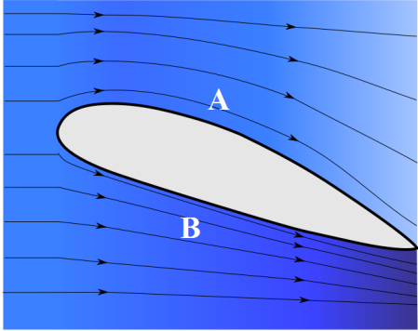

Correct options are:

1. 1 and 3
2. 2 and 4
3. 1 and 4
4. **2 and 3**

Application

1. The sum of all the angles of corners of a 5 point star(not necessary that corners subtend equal angles) is
2. **180 deg.**
3. 300 deg.
4. Between 180 deg and 360 deg
5. Less than 180 deg

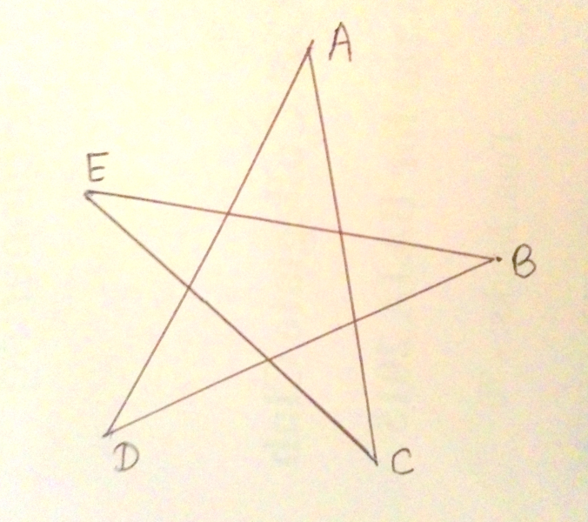

1. How many maximum intersections can be achieved by using 4 lines?
2. 3
3. 4
4. 5
5. **6**
6. If two-third of three-tenth of a number is 30, then one-third of two-fifth of the number is __

a.15

b**. 20**

c. 35

d. 70

4. find the mass of the following body.

Density of the material is 2700kg/m3

1. 524 g
2. 259 g
3. **518 g**
4. 246 g

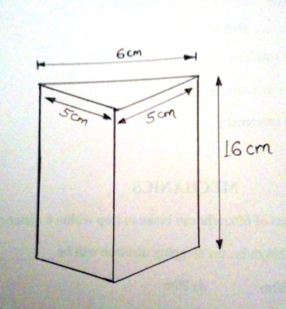

1. The percent increase in the area of a rectangle if each side is increased by 20% is ____
2. 40%
3. 42 %
4. **44 %**
5. 48 %
6. Complete the series

FAG , GAF , HAI , IAH ......

1. **JAK**
2. JAL
3. JAJ
4. JAI
5. Starting from a point , Raju walked 12m North , then 10m to the right , he again turned right and walked 12m , then he turned left and walked 5m . How far and in which direction is he from the starting point
6. 27m toward East
7. **15m toward East.**
8. 05m toward East
9. 15m toward West
10. In a 500m race, the ratio of the speeds of two contestants A and B is 3:4. A has a start of 140m , then A wins by _____
11. **20m**
12. 40m
13. 10m
14. B wins the race
15. If 4 $\sqrt{17}$ + $\sqrt{272 }$ = M , then $\sqrt{425}$ + 17 $\sqrt{17}$ = ?
    1. 1.25M
    2. **2.75M**
    3. 3.15M
    4. 4.25M
16. Find the reaction forces at A and B respectively
    1. RA=17.5 N RB= 17.5 N
    2. RA=3.7 N RB= 3.7 N
    3. **RA=28 N RB= 28 N**
    4. RA=49 N RB= 49 N

